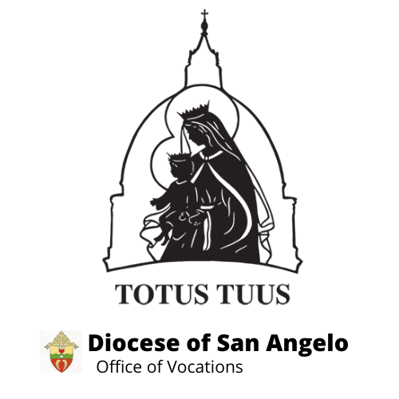

TOTUS TUUS-DIOCESE OF SAN ANGELO
PARISH SUMMER CATECHETICAL PROGRAM
Informational Guide “Blue Book”

Table of Contents
Totus Tuus ~ Totally Yours ................................................................................................................... 3
Our Mission The Five Marks of Totus Tuus
Our Motivation The Five Pillars of Totus Tuus
Our Method The Totus Tuus Curriculum

Daily Schedule ....................................................................................................................................... 6

Grade School Program ........................................................................................................................... 7
Facilities Snacks/Recess
Volunteers and Safe Environment Mass and Confession
Curriculum: 1st – 6th Grades Friday Afternoon

Junior and Senior High School Program .............................................................................................. 11
Facilities Snacks
Supplies Adoration and Confession
Topics: 7th – 12th Grades Thursday Evening Social
Schedule

The Team ............................................................................................................................................. 13
Arrival/Setup Meals
Host Families

Parish Involvement .............................................................................................................................. 15
Parish Potluck Supper Intercessors

Program Fee ......................................................................................................................................... 16
Funding Tips Balance
Registration and Deposit

Parish Coordinator Information ........................................................................................................... 18
Planning Schedule
Checklist

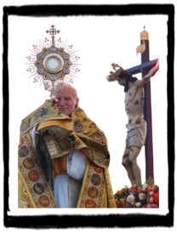
Totus Tuus ~ “Totally Yours”

Totus Tuus is a summer Catholic youth program dedicated to sharing the Gospel and promoting the Catholic faith through evangelization, catechesis, Christian witness, and Eucharistic worship. Our week-long Parish Summer Catechetical Program assists parents and parishes in the evangelizing and catechizing of their youth by supplementing the work they are already doing.

The methodology, structure, content, and enthusiasm of Totus Tuus is concerned not only with teaching the faith, but also igniting the hearts of the team members, young people, and with parishes served. The result has been the formation of young adults who continue to dedicate themselves to the Church’s mission of evangelization.

Our Mission

The mission of Totus Tuus is to inspire in young people a true longing for holiness, a deep desire for daily conversion, and an openness to their vocation by constantly challenging them to give themselves entirely to Christ through Mary and by continually strengthening their prayer lives in imitation of Her.

Our Motivation

Totus Tuus, a Latin phrase meaning “totally yours,” was the motto of Pope John Paul II. Taken from
St. Louis de Montfort’s True Devotion to Mary, it signifies our desire to give ourselves entirely to Jesus Christ through Mary. It also expresses our effort to give our all to every young person we encounter. Through the teams’ example of joy and service, the youth see that these men and women are ON FIRE with the Catholic faith and long for the same thing in their lives.

Our Method

Totus Tuus calls upon college students and seminarians from the Diocese of San Angelo, the Archdiocese of San Antonio and across the United States to carry this mission to every young person they encounter in the parish program. Students are hired for their energy, enthusiasm, love for the faith, commitment to spiritual growth, ability to work with a team, and desire to work with youth.

Parish catechists are grouped into teams of four, each consisting of two men and two women, and are invited to a different parish every week for seven weeks, where they conduct a week-long "parish mission,” teaching and inspiring the parish’s first through twelfth grade youth.

The Five Marks of Totus Tuus

- Proclamation of the Gospel...to arouse faith
- Explanation...examination of the reasons for our beliefs
- Christian Witness...an experience of Christian living
- Celebration of the Sacraments...especially Holy Eucharist and Confession
- Active Witness of the Missionary Nature of the Catholic Church

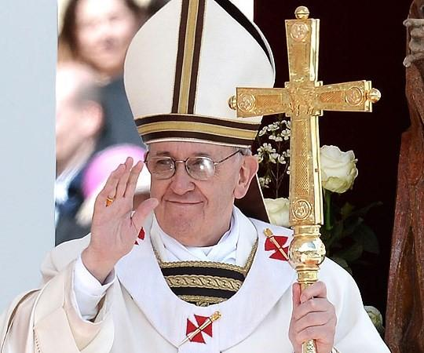
Totus Tuus joins the Church in her proclamation of the Gospel to arouse faith in the youth . Ready with “an explanation…for the reason for your hope” (1 Peter 3:15), Totus Tuus catechists expound upon the reasons for our beliefs and share their personal testimonies with the young people.

Pope Paul VI wrote, "Modern man listens more willingly to witnesses than to teachers, and if he does listen to teachers, it is because they are witnesses” (Evangelii Nuntiandi, 41).

With this in mind, Totus Tuus team members are immersed in a life of prayer and give witness to the fruits of that experience of Christian living to the youth.

Additionally, the daily schedule of the Totus Tuus catechist revolves around the Mass, the Sacraments, and prayer. A summer given entirely to God and the young people of the Diocese of San Angelo would not be possible otherwise.

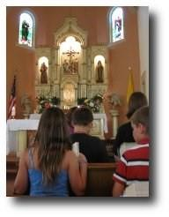
The Five Pillars of Totus Tuus

- The Eucharist
- Marian Devotion
- Catechetical Instruction
- Vocational Discernment
- Fun

The Eucharist has pride of place in the Totus Tuus schedule, for both team members and participants. Prayer—the Liturgy of the Hours, the Rosary, the Angelus, the Chaplet of Divine Mercy, and Adoration of the Blessed Sacrament—provides the structure, but the celebration of the Holy Sacrifice of the Mass is the “source and summit” of the daily schedule.

Totus Tuus catechists and counselors will lead the young people to Jesus for a week; however, Mary will lead them to Jesus for a lifetime. Therefore, Totus Tuus promotes Marian devotion.

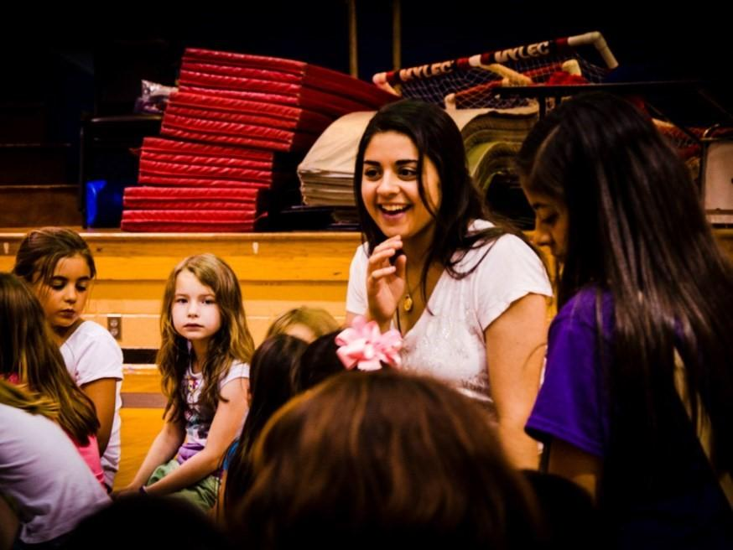
Meditating on the mysteries of the Rosary, we come to see how Mary always leads us to her Son.
Praying with her and to her, we hear her say to us, “Do whatever He tells you” (John 2:5).
An authentic catechesis, rooted in an orderly and systematic explanation of God’s revelation of Himself through the person of Jesus Christ, provides the foundation of the program’s teaching.
Totus Tuus instructs young people in the basic tenets of the Catholic faith to cultivate both a firm intellectual grounding and a solid relationship with Jesus. All of our teaching aims to help young people grow in the understanding of, strengthen their faith in, and, most importantly, develop an intimate friendship with Jesus Christ.

Totus Tuus strives to foster Christian vocations by encouraging young people to begin discerning God’s call in their life to be married, a priest, a religious, or single.

Team members sign a “covenant” in which they promise to be open to and actively discern God’s will for them. Because they are striving to live an authentic Christian life and are actively discerning their vocation, they can better help the youth to do the same.

Finally, Totus Tuus demonstrates that one can be a faithful Catholic and still have fun. Morning “pump up,” silly skits and songs, recess, water fights in the parishes, and all of the many Totus Tuus games, infuse the element of fun in the program.

The Totus Tuus Curriculum

The Sacred Scriptures and the Catechism of the Catholic Church provide the foundation of the catechetical instruction of the Totus Tuus summer catechetical program. Consequently, Totus Tuus has divided the four pillars of the Catechism into a six-year teaching cycle:
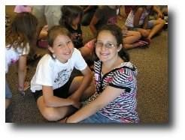

Year One: The Mystery of Salvation
Year Two: The Apostles’ Creed
Year Three: The Sacraments
Year Four: The Commandments
Year Five: The Virtues
Year Six: Prayer and the Our Father

To complement this six-year cycle, Totus Tuus follows a four-year cycle dedicated to the mysteries of the Rosary:

The Joyful Mysteries
The Luminous Mysteries
The Sorrowful Mysteries
The Glorious Mysteries

Daily Schedule

The following is the suggested schedule for use during the week of Totus Tuus. This schedule can be adapted to meet the needs of a particular parish. If you would like to make adjustments to the schedule to accommodate any special circumstances in your parish, please notify the vocations office as soon as possible at 325/651-7500 or rrojo@sanangelodiocese.org.

TEAM

6:30 a.m. | Rise
7:00 a.m. | Breakfast
7:45 a.m. | Morning Prayer (Lauds), Rosary, and Silent/Meditative Prayer

1st - 6th GRADE (7th and 8th Grade Optional) PROGRAM

9:00 a.m. INTRODUCTION
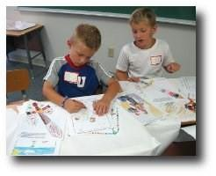
9:15 a.m. Warm-up/Songs
9:30 a.m. CLASS PERIOD #1
10:00 a.m. Snack Break
10:15 a.m. Music Preparation for Mass
10:30 a.m. CLASS PERIOD #2
11:00 a.m. Mass Preparation/Confessions
11:30 a.m. MASS
12:15 p.m. Lunch-Recess
1:15 p.m. Cool Down-Water Break
1:30 p.m. CLASS PERIOD #3
2:00 p.m. Break
2:10 p.m. CLASS PERIOD #4
2:40 p.m. | Gather, Review and Closing Prayer
3:00 p.m.  TEAM | DISMISSAL
3:15 p.m. | Clean-up/Set-up for next day/Team Meeting
3:30 p.m. | Evening Prayer (Vespers) and Chaplet of Divine Mercy
4:00 p.m. | Team Recreation
5:30 p.m. | Supper

JUNIOR & SENIOR HIGH SCHOOL PROGRAM (9th-12th Only Optional)

7:30 p.m. | Introduction/Review
7:45 p.m. | SESSION #1
8:30 p.m. | Break
8:45 p.m. | SESSION #2
9:30 p.m. | Night Prayer (Compline)
9:45 p.m. | DISMISSAL

Grade School Program (1st-6th OR 1st-8th Grade)

The Totus Tuus Grade School Program is designed for children going into first through sixth grades in the coming fall. The Grade School Program runs Monday through Friday. Parishes can choose whether 1st through 6th Grade or 1st through 8th Grade works better for their community.

The students are encouraged to be clear and consistent in their faith. They are shown how to view their Lord as a good Father. This personal relationship gives them the confidence to be Christ’s witnesses in the world around them. Finally, Totus Tuus endeavors to show the youth that a humble and courageous desire to know God must be based upon a steadfast and disciplined life of prayer combined with the reception of the sacraments.

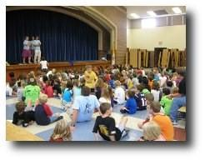
Facilities

In order for the Grade School Program to run smoothly, the
team requests one large hall or room for their main assemblies. (This same room can be used as a lunchroom,
if necessary.) If the group is large, it is helpful to provide a microphone for the main speaker.

The size of the student body and number of teams assigned to each parish will determine how much classroom space is needed. For one team this will usually mean having three or four other classrooms available for use; for two teams, seven or eight classrooms; for three teams, eleven to twelve rooms.

Each classroom should have a chalkboard or a dry-erase board. For the 1st and 2nd grade classroom, it is ideal to have a large enough room to have some empty space near the board for the children to gather on the floor, as well as tables set up with chairs for their activities. Team members will set up the rooms and will return them to their original state at the conclusion of the week following the Friday water fun.

It is vital that the church be available for Mass and confessions every day. If possible, the team might take the students into the Adoration Chapel, if there is one, for a short time during the week; if there is not one, the church would suffice.

Volunteers and Safe Environment

Each parish should assign one person to be a “parish coordinator.” The coordinator will work with the Totus Tuus Office and make arrangements in advance of the team’s arrival to ensure the week runs smoothly. Duties are described throughout this book and listed on page sixteen.

The parish coordinator cannot possibly do everything by him-or herself. As such, we strongly recommend having compliant adult covered volunteers to assist throughout the week. There should be at least two covered volunteers present in the building at all times when the program is in session.

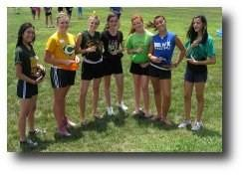
Compliant volunteers can assist the coordinator by setting up drinks and snacks, cleaning the kitchen, sweeping the floors after breaks and lunch, helping those who may become ill, and doing anything else the coordinator may ask.

Compliant volunteers should also be utilized in the classrooms, as Totus Tuus will be unable to provide more than one team member in each classroom. For safe environment purposes, please have at least one covered volunteer per room. Three covered volunteers per room would be ideal—one to stay in the classroom with the teacher; two to accompany kids together out of the classroom when necessary.

During training, team members will be given safe environment guidelines in regard to the classrooms. The Diocese of San Angelo takes the safety of children seriously. Thank you for your assistance in this matter.

No child should ever leave a classroom unattended. If a child has to leave in the middle of a class for any reason, at least one (preferably two) covered volunteer(s) should accompany the child(ren) to his/ her destination.

Compliant volunteers should not be alone with youth in the bathroom, but should instead wait outside in the hall for them. If it is necessary to go into the bathroom with a child, there should be two unrelated covered volunteers present. In the case of bathroom visits, two unrelated compliant “hall-monitors” would suffice.

Classroom covered volunteers who are being disruptive will be asked to report to the parish coordinator. This is usually not a problem for adult covered volunteers.

The parish coordinator will meet with classroom compliant volunteers Monday morning to explain their responsibilities during the week.

All volunteers, regardless of age, must be approved according to Diocesan Safe Environment Policies and Procedures. Additionally, all volunteers must have their background investigated, to assure that there is no history of a sexual crime with children or young people. Finally, all volunteers must have attended a “Protecting God’s Children” Program for Adults and/or the Safe Environment training prior to volunteering.

It is the responsibility of the parish coordinator to make sure the parish volunteers have met these diocesan criteria.

Furthermore, disciplinary issues of children and youth attending Totus Tuus are the responsibility of the parish coordinator.
Snacks/Recess
While formational sessions comprise a large part of the day, Totus Tuus is not school and makes sure the kids have FUN, too! Therefore, we have a break in the morning, recess and “cool down” after lunch, and a short bathroom break in the afternoon.

We ask the parish to provide drinks throughout the day. Water is a necessity, but we also encourage other drinks such as lemonade or Kool-Aid. The children will need drinks set out for them at three points during the day: at the morning snack break (10:00 a.m.), at lunch (12:15 p.m.), and after recess (1:15 p.m.).

We ask that your covered volunteers have the snacks and drinks ready five minutes before each break.
We also ask that the parish provide snacks (cookies, chips, crackers, etc) at the morning break. To make it easier on the parish resources, participating children can be asked to provide one dozen cookies (or a bag of chips, etc).

The children should be asked to bring sack lunches, but drinks may need to be prepared. Some parishes choose to provide lunch for the children, especially on Friday afternoon (see below). The choice is yours; just be clear so the parents know what to expect.

Recess follows lunch. Team sports are encouraged; therefore, children are invited to bring Frisbees, gloves, bats, and balls. The team will participate in recess with the children.

The 2:00 p.m. break is not a snack break.
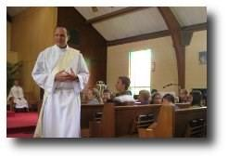

Mass and Confession

It is in the Sacraments, especially in the Eucharist, that Christ Jesus works most fully for the redemption and sanctification of all mankind. We realize that Totus Tuus asks a lot of our priests who are already very busy, and for their presence and participation in the program we are eternally grateful. We have found over the years that celebrating and participating in the sacraments on such an intimate level has a tremendous effect on the children. We strive to help the children participate fully and actively in the liturgy and consider this an integral part of our program. It is the responsibility of the parish coordinator to arrange the liturgical and sacramental events with the priest.

Since the Eucharist is the source and summit of the Christian life, Totus Tuus holds its foundation in the daily celebration of Holy Mass at 11:30 a.m. For the integrity of the program, we also ask that Sacrament of Reconciliation be made available every day before Mass, beginning at 11:00 a.m. We ask all parishes to stick with this schedule if possible. Reconciliation is expected to begin at 11am and Mass at 11:30am. If alternate schedules are necessary, please contact the Totus Tuus office as soon as possible.

The oldest students will be sent to Confession on Monday and younger grades as the week progresses. If your parish has many young people involved in the program, the pastor may find it helpful to invite a fellow priest to assist.

The youth will participate at Mass by serving, bringing up the offertory gifts, and proclaiming the readings and petitions. Totus Tuus team members will lead the children in a few songs during Mass; therefore, it is not necessary to ask the music director or choristers to be there, although they are certainly welcome.

The team will prepare the children for Mass and Confession, and they will practice the songs as well. The children will be expected to behave during Mass—and at all times during the week. Their Friday afternoon schedule depends on it! Again, disciplinary issues are the responsibility of the parish coordinator.

If a priest is unable to hear Confessions and preside at Mass at any point during the week, we ask parish coordinators to do their best to secure a replacement. If no replacement can be found, please contact the Totus Tuus Office immediately. We ask that pastors who are unable to offer the Sacraments or find a replacement allow the Totus Tuus office to find a replacement in good standing. If this is impossible, then the team will take the children to the church to pray the Rosary, Divine Mercy Chaplet, Mid-day Prayer, or the Stations of the Cross.

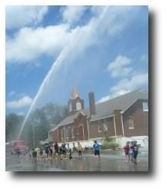
Since 2010, a time of Adoration is now included as part of the grade school schedule. If your parish has a perpetual adoration chapel, we will take the kids there. If not, the team leader will ask Father about exposing the Blessed Sacrament on Thursday afternoon.

Friday Afternoon

On Fridays, we follow the usual schedule through lunch, but then it is modified to allow for “fun time” on Friday afternoon. Students still bring their lunches, or some parishes like to take this opportunity to have a “cook out” (usually hot dogs and chips). After lunch there will be no classes.

Friday afternoon’s festivities can be held in a nearby park or recreation area, or just in a large, open area (the parking lot will suffice) on your church grounds. After lunch there will be a water balloon toss and a “water fight” for which students can bring water guns, squirt bottles, buckets, etc. The team will provide the water balloons. By about 2:40 p.m. the water fight ends and students help the team clean up the area.

The parish is asked to provide water hoses and wading pools or a stock tank, etc. Parishes may also choose to provide popsicles, ice cream, or other treats at the conclusion of Friday afternoon. Some parishes ask the local fire department to send a truck and join in the water fight. This adds a considerable amount of water—and fun!—and is completely optional.

Another Friday afternoon Totus Tuus tradition is the “human sundae.” If the students have behaved well throughout the week, they are allowed to choose one team member to become a human sundae.
The children are asked to bring sundae toppings; the team member will be considered the ice cream. The sundae usually happens before the balloon toss and water fight.

If the children do not behave well, they will not get the sundae. Not all parishes like the idea of the sundae. Other creative options are certainly welcome. Some parishes choose to use shaving cream instead of ice cream toppings.

Parents should be warned that children will be wet and possibly dirty when they are picked up. Please recommend that the students come wearing something that can be ruined; they will not be allowed to change clothes. The team will talk to the children about Friday afternoon at the close of the day on Thursday, giving them the rules of the day, what to bring for the water games, and what to wear.

The day is closed, as is every day, with song and prayer.

Junior and/or Senior High School Program

Totus Tuus offers instruction in the evening for junior and senior high school youth. Junior High youth are those entering the 7th or 8th grades, and Senior High youth are those entering grades 9-12 for the coming school year. These “twilight retreats” meet Sunday through Thursday. Parishes can choose to have only Senior High Youth in the evenings and put the Junior High youth in the day program.

For the benefit of all participants in the program, we ask that a minimum of five students attend in order for the Junior and/or Senior High School Program take place.

We have found that vibrant, faithful, college-aged teachers can effectively impact the youth at this age. Two reasons for this have been noticed: the close proximity of age and the ability to establish mentor relationships, i.e., big brother or big sister.

The Totus Tuus Junior and Senior High School Program comprises instruction, small group discussions, quiet meditation, prayer, and fellowship. The team teaches in such a way as to offer a dialogue in which each person feels respected in his or her most basic dignity.
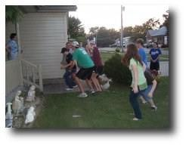
The junior high students will join the senior high students for the evening program; however, their small groups will remain separate to maintain an atmosphere and discussion level that is appropriate for both age groups.

Facilities

Similar to the Grade School Program, the team needs one large hall or room for their main assemblies. If the group is large, it is helpful to provide a microphone for the main speaker.

The size of the student body and number of teachers assigned to each parish will determine how much classroom space is needed. Generally, the team will need two classrooms available for use.

The church needs to be available for Adoration and Confessions Tuesday evening.

Supplies

It would be helpful to have the following supplies for the high school sessions: a chalkboard/dry erase board, CD player, Bibles, 5-7 votive candles, a large crucifix, and a decorative cloth.

Schedule

Each retreat session runs from 7:30 p.m. until 9:45 p.m. There will be time for fellowship, snacks, and two instructional sessions most evenings. The schedule varies, as described below, on Tuesday and Thursday.

Snacks

There is a 15-minute refreshment break at 8:30 p.m. We ask the parish to supply the refreshments Sunday, Monday, and Wednesday evenings. Snacks are not needed Tuesday or Thursday evening.

Adoration and Confession

Tuesday evening, from 8:30-9:30pm, the youth will adore Christ face-to-face during the Exposition of the Blessed Sacrament and will have the opportunity for the Sacrament of Reconciliation. Please be sure to secure the pastor for Exposition and Confessions. If your parish has many young people involved in the program, the pastor may find it helpful to invite a fellow priest to assist. This evening may be moved to another day of the week, usually Wednesday, if necessary; please remember to adjust snacks and schedule the priest accordingly.

Thursday Evening Social

On Thursday evening, the last night of retreat sessions, the team will spend time in fellowship with the youth. Activities for Thursday evening may include anything that allow the team members and youth to interact on a social basis, e.g., a barbecue at the lake, going out for pizza and paintball, Nerf wars, dodgeball, going to a parishioner’s home for a cookout and swimming, or any other unique ideas that the parish may have. This is a great chance for the team to make a personal connection with the youth and establish a mentor relationship.

Unless the parish would like to underwrite the whole cost, the youth are responsible for the cost of the outing, usually no more than $10. The cost of the outing and/or dinner for the Totus Tuus team is the responsibility of the parish.

If the activity is off-site, the youth are to provide their own transportation; the Totus Tuus team members will neither be responsible for, nor will they provide transportation for the youth.

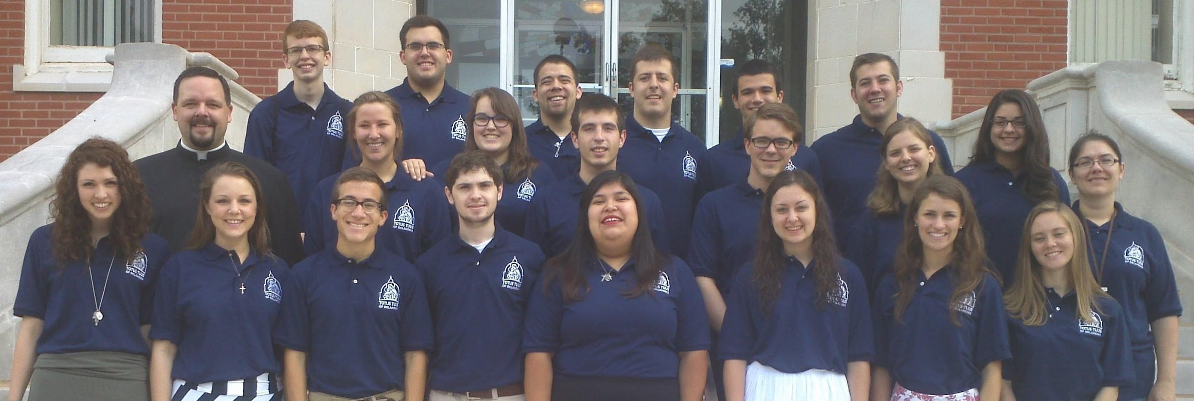

The Team

Each Totus Tuus team consists of two men and two women. The teachers are chosen based upon their commitment to the Catholic faith, desire to teach the faith, love of children, energy and enthusiasm, and leadership abilities.

In order to run a week of Totus Tuus smoothly, the teachers adhere to a well-defined schedule which has as its foundation and backbone a structured prayer life.
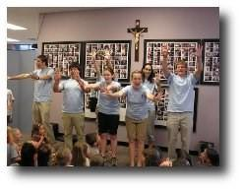
The daily schedule as pertains to the grade school program during the day and the twilight retreats for the older youth in the evenings has already been discussed. This section will lay out the rest of the team’s day and the larger weekly schedule.

Arrival/Setup
The team arrives on the Saturday afternoon prior to the week of teaching. Please inform the team leader if members of the team will be speaking at the Masses that weekend. Speaking at Mass is an excellent opportunity to publicize the coming week with a brief presentation about Totus Tuus. Often this presentation will help bring in more youth to participate in the week’s program.

The team should meet with the parish coordinator and pastor (if available) for a formal meeting and touring of the facilities on Saturday evening. The team will set up the facilities on Sunday afternoon. Due to the early morning and late night scheduling of events, some parishes have found it convenient to provide the team leader with a key to the facilities. If you choose not to do this, then please make sure the team leader knows who will have facility keys for the week.

Host Families

Because the teachers are “out on the road” we ask that the parishes find host families to provide sleeping arrangements, a morning continental breakfast, and possibly snacks to refuel. The team needs two "host homes," one for the men and one for the women. Men and women are to be housed separately. It is easier for the team and the parish if the host homes are close to each other and to the parish, but the team will be grateful for any housing.

The interaction at host homes is valuable for both the team members and the families. However, because of the team’s schedule, it is important to stress that the team may occasionally be late getting home due to team meetings. Also, team members may not always be present at the host families’ homes in the afternoons due to planning and setup.

Housing of team members begins with their arrival Saturday afternoon/evening and ends with their departure the following Friday evening or Saturday morning. Each team will provide their own transportation to and from the parish. It is helpful to give the team driver a list of the names, addresses, phone numbers and directions to the homes for housing and evening meals.

Meals

Plan to provide all of the team’s meals while the team is in your parish. Depending on the specifics of the week’s schedule at your parish, the team may not require dinner at a host family’s every night.

The host family provides a continental style breakfast at 7:00 a.m. Breakfast need not be anything fancy or requiring effort; cereal, fruit, or toast is sufficient.

Lunch for Saturday (if the team has arrived) and Sunday can be at the host families’ homes. Please ask the host families not to plan any activities for the team on Sunday after Mass and/or lunch. This is “team time” and needs to be protected. The teams keep a demanding schedule each week for eight weeks. Like all of us, they require “down time.” Honoring God’s Commandment to keep holy the Sabbath, Sunday afternoon is their time for rest, recreation, and team fellowship, as well as time to prepare for the coming week.

Lunch for Monday through Friday should be provided by the parish or a different parish family (other than the host family) each day at 12:15 p.m. Covered volunteers assisting in the kitchen can prepare the lunch or the team can fix sandwiches from food brought in. Buffet style works best, and whoever is providing the meal may want to bring extra food for the volunteers, priest, etc.

Dinner on Saturday should be scheduled for as early after Mass as possible. It would be ideal if the parish coordinator could host dinner on Saturday evening, as that would give everyone a chance to meet. If this is not possible, please find a family who can have them for dinner.

Dinner on Sunday, Monday, Tuesday and possibly Thursday (see below for Thursday) should be provided at 5:30 p.m. Please arrange for families in the parish to host the team for supper. This allows for more families to be involved in hosting the team and provides an excellent opportunity for the team to interact with families of the parish. A family may prepare and serve the meal, have food brought in, or take the team out to eat.

Since the team is on a tight schedule, please do not schedule supper any earlier or later than 5:30 p.m. unless the team leader is notified. The team will leave the family’s home no later than 7:00 p.m. to return to the parish for the evening program.

The team will not need dinner on Wednesday if the parish is hosting the potluck. If there will not be a potluck, please find someone to host the team for dinner at 5:30 p.m. If the potluck will be on another evening, please plan accordingly.

The team will not need dinner on Thursday if their evening social with the junior high and senior high school youth involves a meal. If a meal is planned for the social, the cost of the meal for the team should be provided by the parish. If no meal is planned within the Thursday night activity, please find someone to host the team for dinner at 5:30 p.m.

The need for dinner on Friday should be determined when the team leader calls the parish coordinator during the week before the program.

Parish Involvement

The focus of the Totus Tuus program is obviously on the youth of your parish; however, the entire parish can be involved. We have already mentioned the need for covered volunteers to help during the day program and host families to house and feed the team(s) during the week. Here are two additional ways to get a larger portion of the parish involved.

Parish Potluck Supper

The parish is asked to sponsor a potluck supper for the children, their families, and all parishioners on Wednesday evening. The potluck supper should begin at 5:30 p.m. and wrap up around 7:00 p.m. to allow the team time to prepare for the evening program. Once again, this activity and the time are suggested; the day and time can be adapted to meet the needs of each individual parish.

We encourage this to be a parish-wide event. This gathering gives the team an opportunity to meet families and other parish members. It is also an excellent opportunity for the parents to meet and get to know the teachers, where they are from, etc. During the evening the team leader will introduce the team and explain a little about the history and mission of Totus Tuus. To close the night, the team will lead the children in some songs for the parish.

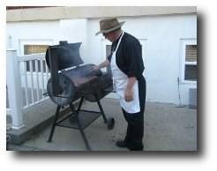
Some parishes have adopted alternate means of having the parents and team meet. For example, one parish has “special lunches” for its grade school program. Parents and team members join the kids for a brown bag lunch at the parish; each grade, or cluster of grades, has its own special lunch on a different day, in room separate from the rest of the grades. If you have an alternate plan that works well, please let the Totus Tuus Office know.

Intercessors

While the team is at your parish, and even before they arrive, we recommend recruiting intercessors to pray for and provide spiritual assistance to the team, the youth, the coordinators and volunteers, and the pastor of your parish. This is a great way to involve parishioners who don’t have school-aged children attending Totus Tuus.

Ask the regular Adorers, daily Mass goers, members of the Altar Society, the Knights of Columbus, or the Rosary Guild—indeed, anyone you can think of—to commit to daily or weekly prayer for the team, the participants, and the program. They can pray in whatever way they like: offer Masses, holy hours, rosaries, chaplets; intercede with petitionary prayer; recite the traditional memorized prayers; offer a day of fasting—the possibilities are as numerous as your parishioners.

Program Fee

Below is the cost to a parish for hosting a team and the maximum number of youth per team.

Number of Teams Max. Youth Served* Cost
- team (4 persons) 100 youth $1500
- teams (8 persons) 200 youth $3000
- teams (12 persons) 200 youth $4500
- teams (16 persons) 400 youth $6000

* “Maximum youth served” applies only to those youth served through the Grade School Program. There is not a maximum number of students for the Junior and Senior High School Program.

Funding Tips

The amount the parish charges for participating youth is entirely up to the parish. We recommend around $20 per child or $50 for families of three or more. At $20/child, a parish with 80 youth in the Grade School Program and 30 youth in the Junior and Senior High School Program would about cover the cost of 1 team. Another way to fund is to pad the annual Religious Education fee for registration to include the cost of Totus Tuus.

Throughout the years, many Knights of Columbus Councils, parish men’s groups, altar societies, and other parish groups have assisted in bringing the program to various parishes. Would a group at your parish be willing to help sponsor Totus Tuus?

Registration and Deposit

A registration form is available on our website at https://www.dosavocation.org/ under the “Resources/Totus Tuus” tab. If you have difficulty with the website, please contact the Vocations office as soon as possible at 325/651-7500 or rrojo@sanangelodiocese.org.

Each parish must choose three potential weeks for Totus Tuus. This allows us to be able to schedule all of the parishes who wish to host the program.

Each parish must pay a deposit fee of $500 per team to reserve a date and a team. (Therefore, if your parish has requested two teams, the deposit is $1000.) The deposit is non-refundable (see Cancellation Policy on page 16.

The deposit must be mailed at the same time as the Parish Registration Form. Registrations will be accepted on a first-come, first-served basis. All registration forms and deposits are due by February 15, 2022.
There are two reasons for this early date. First, the parish coordinator needs time to make the necessary arrangements, to recruit covered volunteers, and to advertise the summer program. Second, the number of parishes requesting the program determines the number of teams that will be needed for the summer and, thus, how many teachers will need to be hired. Teacher applications are due February 15, and teachers will be hired as soon as possible.

A letter of confirmation will be sent to each parish detailing the scheduling information. Parishes will be scheduled based upon the history and/or willingness of the parish to provide the daily sacraments during the week of Totus Tuus. After that is determined, parishes will be scheduled on a “first-come, first-served” basis.

Balance
Parishes are asked to remit the balance of the program fee to the Totus Tuus office two months before the program begins in their parish. Parishes will be invoiced for the remaining balance after the initial reservation deposit is paid.

Checks should have “Totus Tuus” in the memo and be made payable and mailed to:
Diocese of San Angelo
Attn: Vocation Office
802 Ford Street
San Angelo TX, 76905
NOTE: We are willing to discuss ways to make Totus Tuus more affordable for your parish. If the cost of the program is the only deterrent to your parish scheduling Totus Tuus or if there are payment scheduling problems, please contact the Vocations office as soon as possible at 325/651-7500 or rrojo@sanangelodiocese.org.

Cancellation Policy
The ability of Totus Tuus of San Angelo to minister to parishes and young people depends upon the commitments of parishes. As a reminder, Totus Tuus of San Angelo will not schedule the program without having received a parish deposit of $500 per team. The deposit is non-refundable and nontransferrable to another parish.

In the event that a parish needs to cancel the commitment to Totus Tuus, the following schedule determines the amount owed.

Cancellation before March 1, 2022: Deposit is retained and $0.00 is owed to Totus Tuus.
Cancellation before April 1, 2022: 50% of the remaining balance is owed to Totus Tuus.
Cancellation after April 1, 2022: 100% of the remaining balance is owed to Totus Tuus.

Scheduling:

Weeks will be officially assigned on a first-come, first-served basis. Initial schedules will be sent out by February 20 of every year. If spots are still available after that, parish registrations will be assigned as they come.

Parish Coordinator Planning Schedule

Hosting a Totus Tuus team is a great responsibility for the Parish Coordinator. We have found the following schedule helpful for first-time parish hosts.:

Prior to Submitting a Parish Request Form:
- Decide which three weeks the Pastor is available to be present during the day for the Totus
Tuus program (see page 9 & page 19). PLEASE CHOOSE THREE OPTIONS.

Submit the Parish Request Form:
- The deadline to submit a parish request form is February 15, 2022
- Tentatively reserve the necessary parish facilities for those weeks.

Upon Receiving Confirmation of your Parish Week:
- Reserve facilities and place the week on the Parish Calendar.
- Talk with the pastor to schedule a priest(s) for daily Mass and Confession.
- Talk with the pastor to schedule a priest for adoration and Confession Tuesday night.
- Talk with the pastor to schedule adoration Thursday afternoon.

Four Months Prior to the Totus Tuus Week:
- Determine the fee per student (if any).
- Inform parishioners via the parish bulletin of the dates of the program and a little bit of information about Totus Tuus.
- Begin recruiting and arranging for separate Host Families for the men and women on the Totus Tuus teams (see page 13 for details). We have found that making specific phone calls to potential host families works better than asking for volunteers in the bulletin.
- Begin recruiting covered volunteers to help during the daytime program.
- Arrange for Friday afternoon “fun time” (fire department, stock tank, popsicles, etc.).

Two Months Prior to the Totus Tuus Week:
- Request with the Pastor to announce and promote the program from the pulpit.
- Finish recruiting covered volunteers.
- Begin Enrollment and Registration
One Month Prior to the Totus Tuus Week:
- Pay your final balance to the Totus Tuus Office of the Diocese of Tulsa.
- Recruit intercessors to pray for the team, youth, coordinators, and volunteers.
- Arrange how snacks will be provided for the day and evening programs.
- Arrange families (different than those providing housing) to provide meals for the team during the week.
- Arrange and organize Thursday Evening Social.
- Organize and promote the potluck, as well as set-up and clean-up.

Two Weeks Prior to the Totus Tuus Week:
- Double check with the Pastor, all host families, all volunteers, and those arranging meals
- Announce and take registrations after all Masses.
- Create a “manual of directions” for the team driver that includes addresses and names of all host families and meal hosts.
- Finalize Thursday Evening Social activities.
]
Tuesday Prior to the Totus Tuus Week:
- Expect a phone call from the leader of your Totus Tuus team to go over details of the week.

Parish Coordinator Checklist

The responsibilities of the Parish coordinator for the program are as follows:

- Reserve facilities:
- Classrooms and gathering space for the week and help the team set up if possible.
- Fields or other play area for recess and Friday afternoon “fun time.”
- Large room for Wednesday potluck.
- Arrange for Friday afternoon “fun time” supplies, e.g., fire department, stock tank, popsicles.
- Promote the program and collect registrations.
- Collect the Enrollment Forms.
- Ensure all youth have all necessary diocesan photo release and permission slips on file.
- Recruit covered volunteers to help during the day program.
- At least 2 covered volunteers (those who have met diocesan safe environment standards) on-site all times children are present.
- Additional covered volunteers dependent upon the number of participants, most needed between 9:30am and 1:30pm for lunch and breaks.
- Covered volunteer help for the 1st & 2nd grade classrooms for the duration of the day.
- Recruit intercessors to cover the team and your young people in prayer.
- Arrange how snacks and drinks will be provided for the day and evening programs.
- Find separate host families for men and women.
- Host families are asked to provide sleeping arrangements, a morning continental breakfast, and possibly snacks to refuel.
- Arrange families (different than those providing housing) to provide meals for the team during the week.
- Schedule a priest(s) for daily Mass and Confession (see p. 9 in the Blue Book).
-Confessions: 11am daily, Monday-Friday.
-Mass: 11:30am daily, Monday-Friday.
- Schedule a priest for Adoration and Confession Tuesday night, 8:30-9:30 pm.
- Organize and promote the potluck, as well as set-up and clean-up.
- Meet with the team upon their arrival.

NO LATER THAN the Tuesday by 2pm prior to arrival, the team leader will contact the parish coordinator listed on the Parish Registration Form* to make all necessary arrangements. The team will arrive on the Saturday of the scheduled week, unless other arrangements have been made.

*The Parish Registration Form and other forms that the parish coordinator may need are available on our website at https://www.dosavocation.org/ .

Totus Tuus - Diocese of San Angelo
Host Family- What to Expect

Thank you so much for volunteering to host two of our Totus Tuus team members for the week! Your hospitality is a great help in the effort it takes to bring this great program to our parish community.

The team members assigned to stay in your home are:
- ________________________________
- ________________________________

Arrival date is: __________________ and departure date is: ________________.

Should you have any questions, feel free to contact the Parish Coordinator:

___________________________________________________________________________________________.

The interaction at host homes is valuable for both the team members and the families. However, because of the team’s schedule, it is important to stress that the team may occasionally be late getting home due to team meetings. Also, team members may not always be present at the host families’ homes in the afternoons due to planning and setup.

Housing of team members begins with their arrival Saturday afternoon/evening and ends with their departure the following Friday evening or Saturday morning. Each team will provide their own transportation to and from the parish.

Meals
The host family is asked to provide a continental style breakfast at 7:00 a.m. Breakfast need not be anything fancy or requiring effort; cereal, fruit, or toast is sufficient.

Lunch for Saturday (if the team has arrived) and Sunday can be at the host families’ homes. We ask that the host families not plan any activities for the team on Sunday after Mass and/or lunch. This is “team time” and needs to be protected. The teams keep a demanding schedule each week for eight weeks. Like all of us, they require “down time.” Honoring God’s Commandment to keep holy the Sabbath, Sunday afternoon is their time for rest, recreation, and team fellowship, as well as time to prepare for the coming week.

Dinners during the week- The parish will be making arrangements for meals on Sunday, Monday, Tuesday and possibly Thursday evening at 5:30. Wednesday we will have a parish wide potluck that you are also invited to attend. Lunches during the week will also be provided.

